Resume

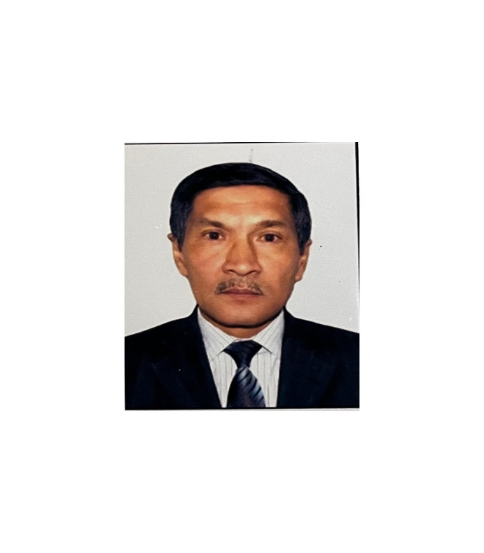 | Full Name  (by identity card) | Baitasov Murat Omarovich
 | Date of Birth | 25.05.1957
 | Gender (male / female) | Male
 | Nationality | Kazakh
 | Citizenship | Kazakhstan
 | Mobile phone,  Email | 87017053400, baitmurat@mail.ru
Place of work: | NAO "Kazakh National Agrarian Research University"
Position: | Senior lecturer of Department "Forest Resources, Hunting and Fisheries"
Academic degree, title:
Education: | Higher, Almaty, Kazakh Agricultural Institute, specialty: Forestry Qualification "Forestry Engineer" 1975-1980
Work experience: | 1980-1982- forester of the Ushtobinsky forestry enterprise of the Taldy-Kurgan region.  1982-1987- head of the financial and pension department of the Kirovsky district military commissariat of the Taldy-Kurgan region.  1987-1992- chief engineer of the Kirovsky district combine of municipal enterprises of the Taldy-Kurgan region.  1992-2003- deputy chairman of the board of the Birlik bank of Taldy-Kurgan 2003-2020 senior lecturer of the department of "Forest resources and hunting" since.  October 2024 to the present - senior lecturer of the department of "Forest resources, hunting and fisheries" Kazakh National Agrarian Research University.
International internships: | -
Activities in the service sector (within and outside the institution): | -
Scientific activity Head and/ or performer of research in the Republic of Kazakhstan | Co-executor of research in the Republic of Kazakhstan on the topic: “Integrated use of non-timber forest resources in the Akmola and Kostanay regions”, 2006-2008, Almaty.
Training of highly qualified personnel: | According to the educational program 5B080700 - "Forest Resources and Forestry", there are 48 bachelors.
Authorship or co-authorship in scientific or experimental design developments: | In co-authorship, the “Recommendations for the integrated use of non-timber forest resources in the Akmola and Kostanay regions” were published, based on the results of scientific research conducted in 2006-2008, Almaty, 2010
Educational and methodical publications: | 1. "Forest Inventory" guidelines for laboratory work for students majoring in 5B080700 - "Forest Resources and Forestry", Zhaniya-Poligraf printing house, Almaty, 2012.  2. "Forest Inventory" guidelines 5B080700 - resource inventory and laboratory work for students majoring in forestry, Almaty, 2012.  3. Guidelines for conducting educational practice "Forest Inventory" for students majoring in 5B080700 - "Forest Resources and Forestry", Zhaniya-Poligraf printing house, Almaty, 2013.
Scientific publications: | 26 scientific articles were published, 2 of them in the scientific journals “ZHARSHY” and “VESTNIK”  1. “The yield of wild berries, medicinal and food plants in the forests of Akmola and Kostanay regions of Kazakhstan” Scientific journal No. 4 (52), BULLETIN of Semey, 2010.  2. Kostanay oblysy Arakaragay orman sharuashylygy memlekettik mekemesinde zhabayy darylik zhane azyk – tuliktik asimdikterdin ononimdilik koryn anyktau. “ZHARSHY” GSZh, Almaty, 12.2010.  3. "Determination of the yield of wild medicinal and food plants in the Arakaragay State Forestry Department of the Kostanay Region." International scientific and practical conference dedicated to the 60th anniversary of forestry education in Kazakhstan, Almaty, 2008.  4. "The yield of wild berries, medicinal and food plants by Results of research in the forests of the Northern regions of Kazakhstan" International scientific and practical conference dedicated to the 80th anniversary of KazNAU, Almaty, 2010.
Rewards: | - "For the achievements of the KazNAU" medal  - Golden Jubilee Medal of the 85th Anniversary of KazNAU (Order No. 647 dated November 18, 2015)  - Medal "Higher Forestry Education 70 Years" in Kazakhstan (Order No. 3 November 2018)  - Badge "For the achievements of the Agrarian Policy, Culture and Forestry in Kazakhstan" (Order No. 70 dated April 20, 2021)  - Certificates of Honor and Diplomas of KazNAU for conscientious work and active participation in the sports and social life of the university.
Knowledge of languages: | Kazakh – native, Russian – fluent.

